Sri Lanka Institute of Information

Technology



Lab Submission

<Lab sheet No 07>

**<IT24101016>**

**<Jayasooriya J.M.V.D.>**

**Probability and Statistics| IT2120**

B.Sc. (Hons) in Information Technology

**Exercise**



**Question 01**

A train arrives at a station uniformly between 8:00 a.m. and 8:40 a.m. Let the random variable X represent the number of minutes the train arrives after 8:00 a.m. What is the probability that the train arrives between 8:10 a.m. and 8:25 a.m.?

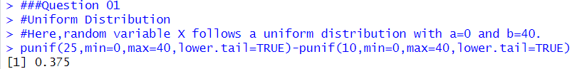

**Question 02**

The time (in hours) to complete a software update is exponentially distributed with rate λ = 1^3. Find the probability that an update will take at most 2 hours.

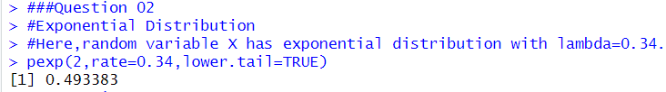

**Question 03**

Suppose IQ scores are normally distributed with a mean of 100 and a standard deviation of 15.

1)What is the probability that a randomly selected person has an IQ above 130?

2)What IQ score represents the 95th percentile?

